Ideation Phase
Brainstorm & Idea Prioritization Template

Date | 20-July-2026
Team ID
Project Name | AI-Enabled Student Admission System
Maximum Marks | 4 Marks

Brainstorm & Idea Prioritization Template:
Team Gathering, Collaboration, and Selecting the Problem Statement Our team brainstormed core operational friction points in traditional university admissions processes. Below are the prioritized focus items generated during our session
Step-1: Team Gathering, Collaboration and Select the Problem Statement
Section 1: How Might We Statement Configuration
Our engineering group gathered to pinpoint the single greatest friction point holding back university registration teams. After tracking operational bottlenecks, we decided to focus our design efforts on a central problem statement.
Step-2: Brainstorm, Idea Listing and Grouping
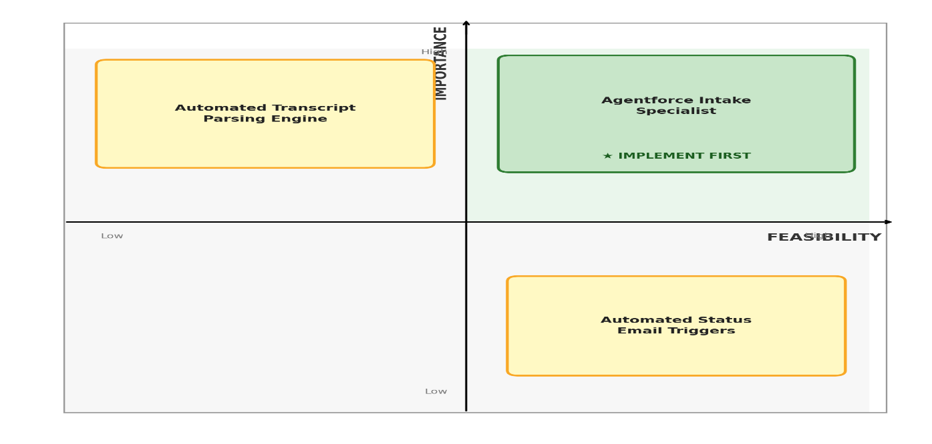

Person 1 (Admissions Core):
- Sticky 1: "Automated Transcript Parser: Extract GPA and course prerequisites using AI recognition dynamically."
- Sticky 2: "High-Risk Application Identifier: Flag incomplete profiles automatically before routing to advisors."
Person 2 (AI Support Layer):
- Sticky 1: "Agent force Intake Agent: Introduce a conversational tier-1 assistant to answer enrolment steps."
- Sticky 2: "Smart Discount Routing: Create structured approval flows for fee waivers over critical thresholds."

Step-3: Idea Prioritization
1. Top Right Quadrant: High Importance and High Feasibility (Implement First)
- Feature Sticky Note: Agentforce Intake Specialist
- System Value: Provides immediate multi-turn conversational answers to prospective student queries, significantly offloading routine work from the intake support desk staff.
2. Top Left Quadrant: High Importance and Medium Feasibility (Plan Next)
- Feature Sticky Note: Automated Transcript Parsing Engine
- System Value: Dynamically extracts GPA records and filters incoming registration data fields against institutional eligibility rules to block incorrect profiles automatically.
3. Bottom Right Quadrant: Low Importance and High Feasibility (Quick Wins)
- Feature Sticky Note: Automated Status Email Triggers
- System Value: Sets up instantaneous platform alert updates to smoothly email candidates whenever their registration checkpoint moves to a new stage block.

